Ref. No: Date: 04.08.2023

Notice Regarding 4th Semester Hons Internal Exam
It is hereby notify to all 4th semester hons students that an internal examination will be held on 14th August 2023 at 11am in room no 205. All students must attain positively within stipulated time.

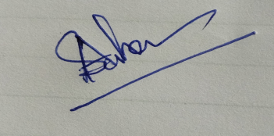
HOD
Department of Chemistry

